**Project Design Phase-II**

**Data Flow Diagram & User Stories**

|  |  |
| --- | --- |
| Date | 20 June 2025 |
| Team ID | LTVIP2025TMID55634 |
| Project Name | Booknest: Where Stroies Nestle |
| Maximum Marks | 4 Marks |

**Data Flow Diagrams:**

A Data Flow Diagram (DFD) is a structured visual tool used to represent the flow of information within a system. It provides a clear and concise graphical depiction of how data moves through a system, including where it originates, how it is processed, and where it is stored.

DFDs are instrumental in illustrating the functional aspects of a system without delving into technical details. They help stakeholders understand how inputs are transformed into outputs and how data interacts with various components of the system. When designed clearly and accurately, a DFD effectively communicates system requirements and serves as a valuable reference throughout the development lifecycle

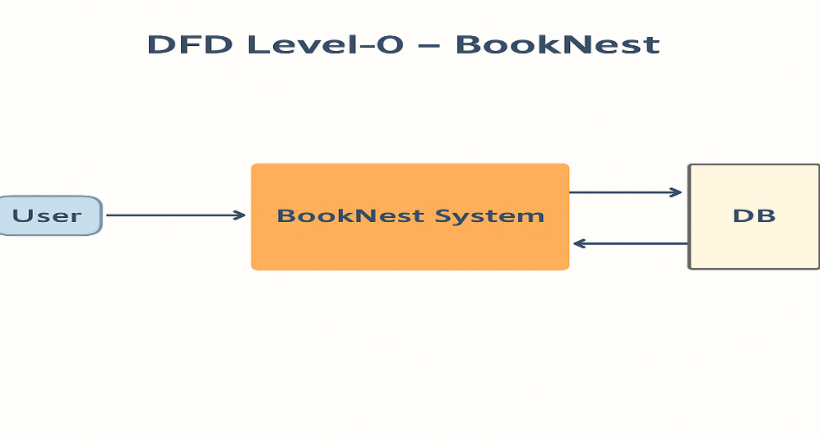 **Example:** [**(Simplified)**](https://developer.ibm.com/patterns/visualize-unstructured-text/) 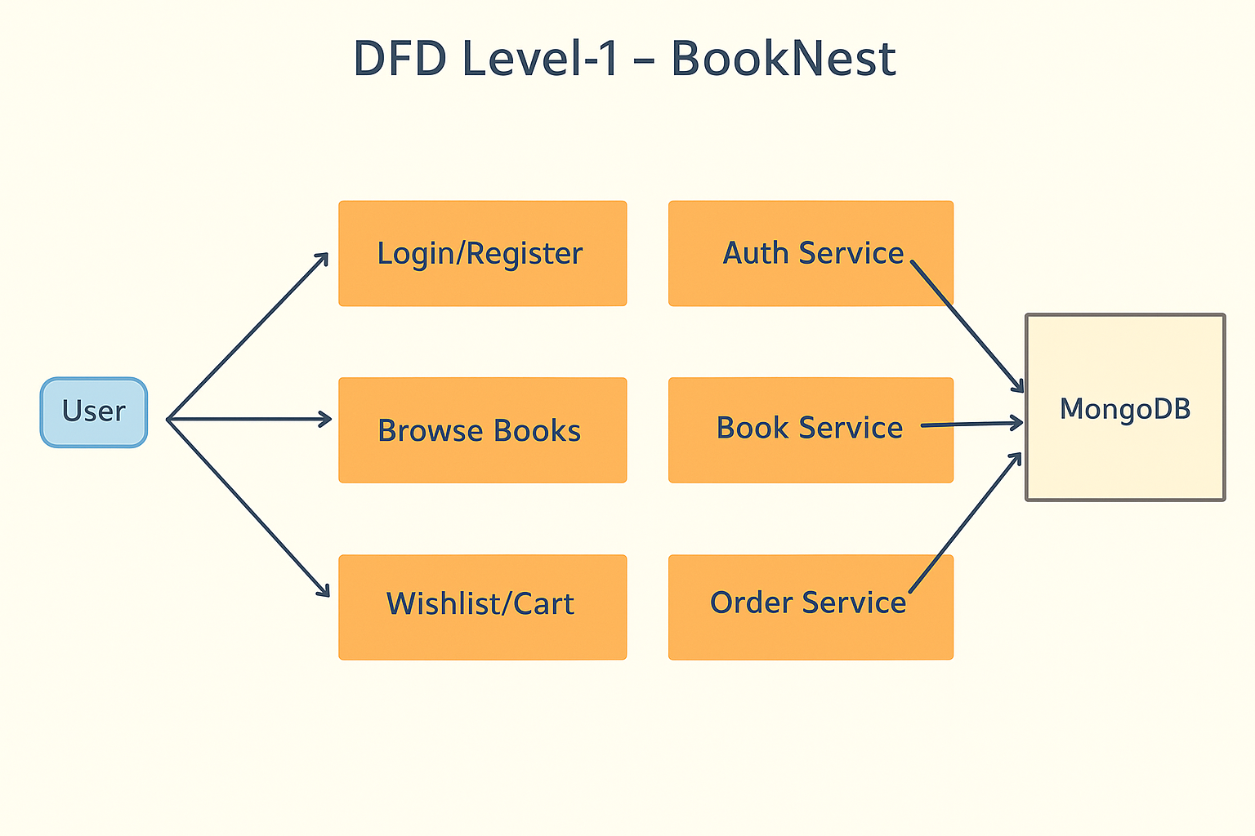

* User sends request (register, login, browse books, order, wishlist)

**Data flows:**

* **User Interactions:**  
  Data enters the system through various user interactions such as login, applying book filters, managing wishlists, and adding items to the cart.
* **System Operations:**  
  The system processes these inputs and performs read/write operations on the backend database, specifically interacting with collections such as **User**, **Book**, **Order**, and **Wishlist** within **MongoDB**.
* System responds with book list, dashboard, confirmation
* System stores/updates data in MongoDB

**User Stories**

| **User Type** | **Functional Requirement (Epic)** | **User Story #** | **User Story / Task** | **Acceptance Criteria** | **Priority** | **Release** |
| --- | --- | --- | --- | --- | --- | --- |
| Customer (Web) | Registration | USN-1 | As a user, I can register with email and password. | I can access my dashboard | High | Sprint-1 |
| Customer (Web) | Registration | USN-2 | As a user, I receive a confirmation email after registration. | I receive & confirm via email | High | Sprint-1 |
| Customer (Web) | Registration (OAuth) | USN-4 | As a user, I can register using Gmail authentication. | I register via Gmail | Medium | Sprint-1 |
| Customer (Web) | Login | USN-5 | As a user, I can log in using email and password. | I access my dashboard | High | Sprint-1 |
| Customer (Web) | Dashboard | USN-6 | As a user, I can view my orders and wishlist on a personalized dashboard. | Dashboard shows my books and orders | High | Sprint-2 |
| Customer (Web) | Wishlist | USN-7 | As a user, I can add/remove books from my wishlist. | Heart icon toggles and saves correctly | Medium | Sprint-2 |
| Customer (Web) | Book Browsing | USN-8 | As a user, I can browse and filter books by genre/author. | Filters update book list instantly | High | Sprint-2 |
| Customer (Web) | Order Placement | USN-9 | As a user, I can add books to my cart and place orders with delivery address. | Order confirms with address saved | High | Sprint-3 |
| Customer (Web) | Profile Management | USN-10 | As a user, I can update my profile (name/email/password). | Changes are saved and reflected on next login | Medium | Sprint-3 |
| Administrator | Admin Dashboard | USN-11 | As an admin, I can manage all books, users, and orders. | Admin panel updates backend & reflects in UI | High | Sprint-4 |
| Administrator | Order Management | USN-12 | As an admin, I can update order status (Processing, Shipped, Delivered). | Orders update and show status in user dashboard | Medium | Sprint-4 |
| Administrator | Book Image Upload | USN-13 | As an admin, I can upload book images during book creation/editing. | Book cover appears correctly in book listing | Medium | Sprint-4 |